CSIT314 Software Development Methodologies - Group Project

Sprint 1 - US4: View user profile
Interior Design Platform - User Admin
All diagrams were drawn in draw.io. Open "US4 View user profile.drawio" in this folder to edit them - each diagram is its own page in that file. The exported images are in the "diagrams" folder.

Assumptions
- The system is the Interior Design Platform from the project specification. Sprint 1 covers the User Admin's log in / log out and managing user profiles and user accounts (US1-US12).
- A user profile is a user group, e.g. User Admin, Interior Designer, Customer or Platform Manager. It has a name, a description, a list of permissions (what its users can do) and a status (Active or Suspended). Every user account belongs to exactly one user profile and gets that profile's permissions.
- We follow B-C-E: the actor only talks to the boundary (page), the boundary only talks to the controller, and the controller works with the entity classes. There is one controller per use case.
- The boundary checks all the input (required fields, lengths, formats, e.g. not suspending your own profile) and trims spaces, then passes an entity object on. The controller just calls the entity and returns the result. The entity checks for duplicates and the database state (e.g. name already used, only Active rows are changed), then saves.
- Being logged in as a User Admin is a precondition (UC1), so this use case never checks it again. loginRequired in app.py only sends someone with no session to /login.
- The User Profiles page lists every profile with a "View" link (the list is part of the search / list profiles story, so it is only shown here as the starting point).
- Suspended profiles can still be viewed. Their status shows as Suspended.
- Viewing never changes any data. The page is read-only and links to Update (US5) and Suspend (US6).

1. User story
Story ID | US4
User story | As a user admin, I want to view a user profile so that I can check the group's details and what its users can do.
Actor | User Admin
Priority | High
Story points (estimate) | 2
Acceptance criteria | 1. Given I am on the User Profiles page, when I click "View" on a profile, then its details page opens.  2. The details page shows the profile name, description, status (Active or Suspended) and every permission the group has.  3. Given the profile is suspended, when I view it, then I still see its details with the status "Suspended".  4. Given the profile does not exist (e.g. a wrong link), when I open it, then I am taken back to the list with "User profile not found".  5. Viewing a profile does not change anything.
Tasks | T4.1 Write the use case description and draw the use case diagram  T4.2 Draw the B-C-E class diagram and the sequence diagram  T4.3 Draw the wireframes for the list, the details page and the not-found message  T4.4 Write a script to generate test data (about 100 user profiles) so there is enough data to view  T4.5 Write the unit tests first (TDD) for UserProfile.getUserProfile() and ViewUserProfileController  T4.6 Code UserProfile.getUserProfile()  T4.7 Code ViewUserProfileController  T4.8 Code ViewUserProfilePage (details, status badge, permission list, not-found message) and add the View link  T4.9 Run the test cases, fix bugs and push to the repo so the CI pipeline runs the unit tests

2. Use case diagram
The user story becomes one use case, UC4 View user profile. The User Admin is the only actor.
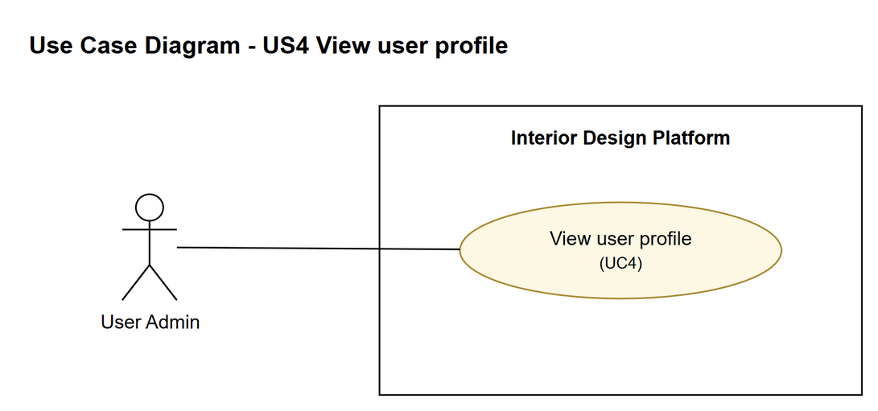
Figure 1: Use case diagram for US4 View user profile

3. Use case description
Use case | UC4 View user profile
Actor | User Admin
Brief description | The User Admin opens one user profile to check its details and what its users are allowed to do.
User story | US4: As a user admin, I want to view a user profile so that I can check the group's details and what its users can do.
Preconditions | The User Admin is logged in (UC1).  The User Admin is on the User Profiles page.
Trigger | The User Admin clicks "View" next to a user profile.
Basic flow | 1. The User Admin clicks "View" next to a user profile.  2. The system gets that user profile.  3. The system shows the profile's name, description, status and the list of permissions.  4. The User Admin checks the details. From here they can go back to the list, or choose Update (UC5) or Suspend (UC6).
Alternative flows | 2a. The profile can't be found (e.g. a wrong link): the system shows the list again with "User profile not found".
Postconditions | Nothing in the system is changed.

4. Wireframes
The wireframes were drawn in draw.io. They are low-fidelity: they show the layout and the flow, not the final colours. The orange numbers match the notes under each screen.

4a - User Profiles page
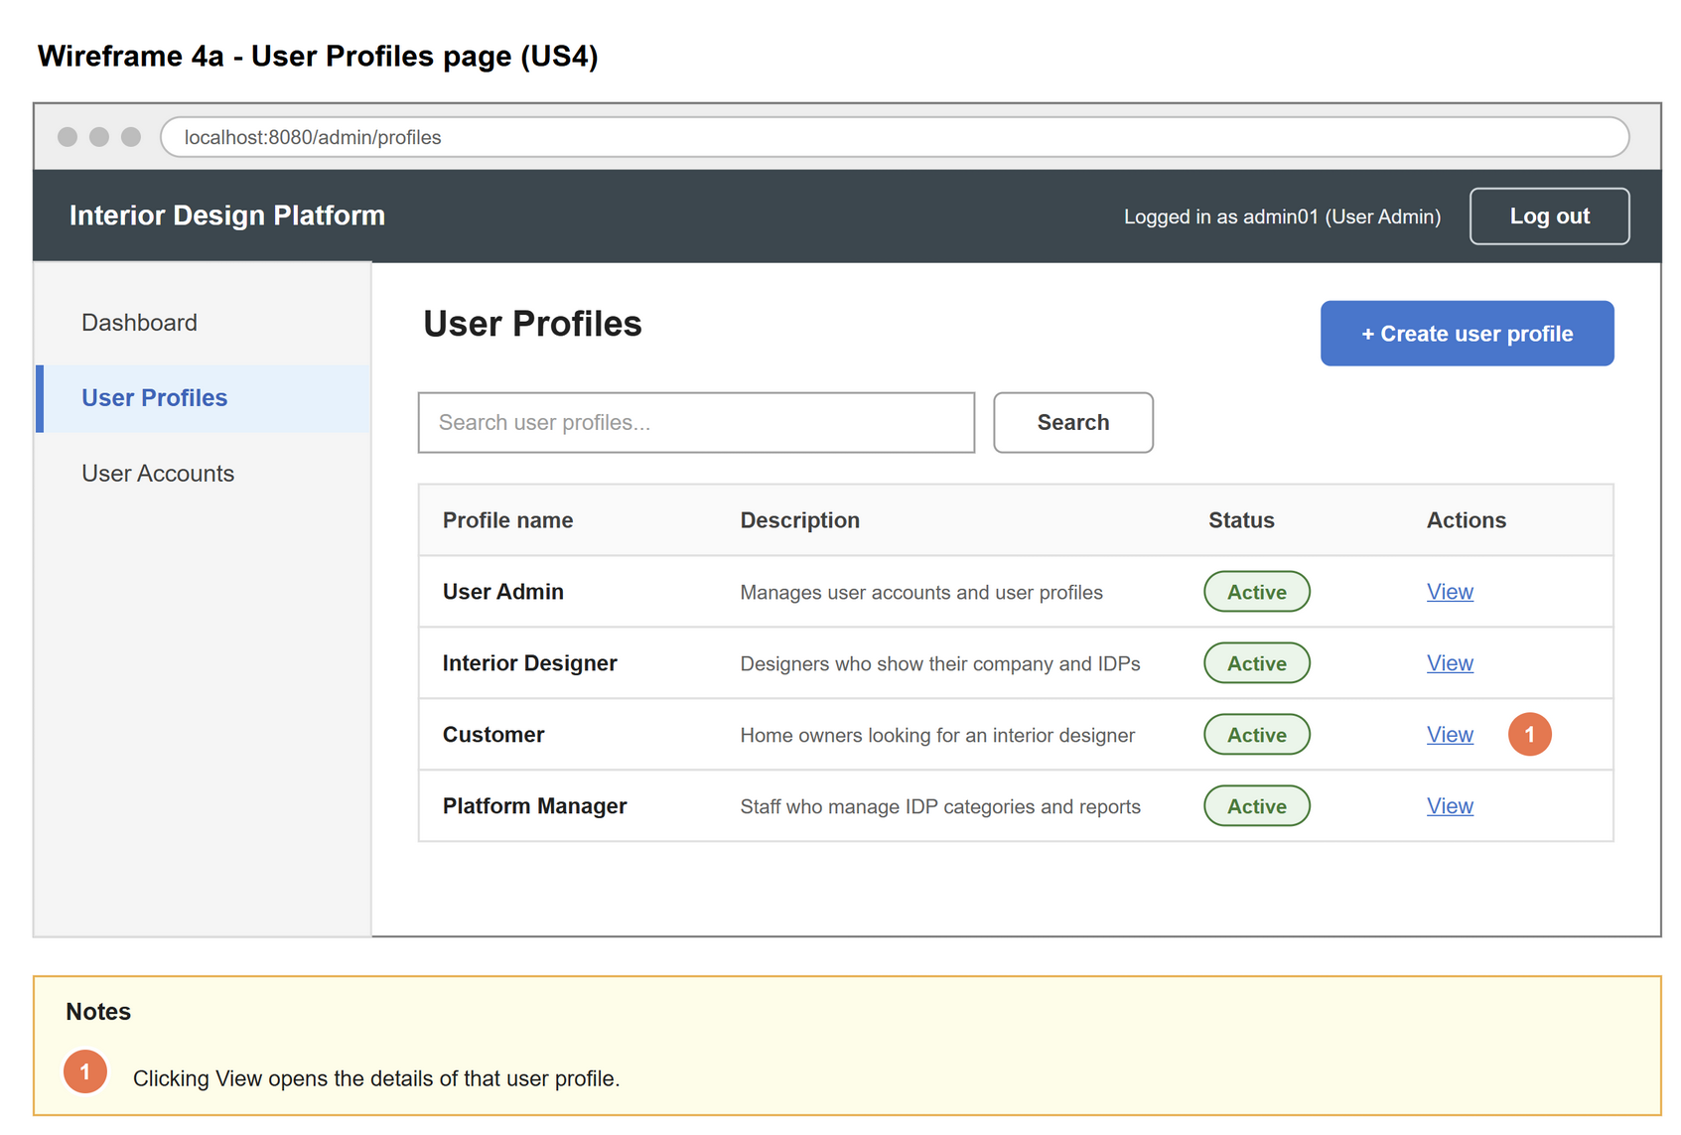
Figure 2: Wireframe 4a - User Profiles page (US4)

4b - User profile details
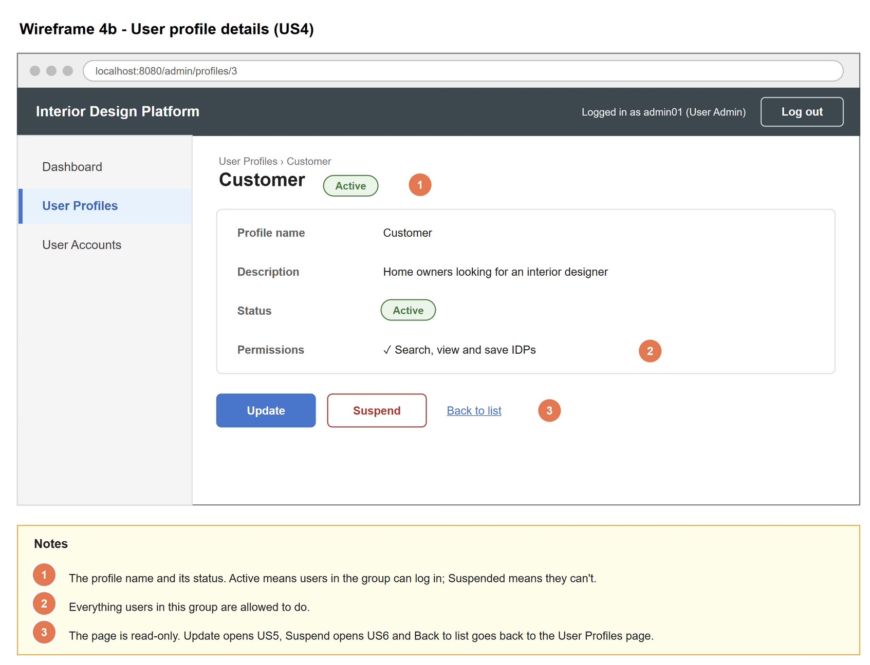
Figure 3: Wireframe 4b - User profile details (US4)

4c - User profile not found
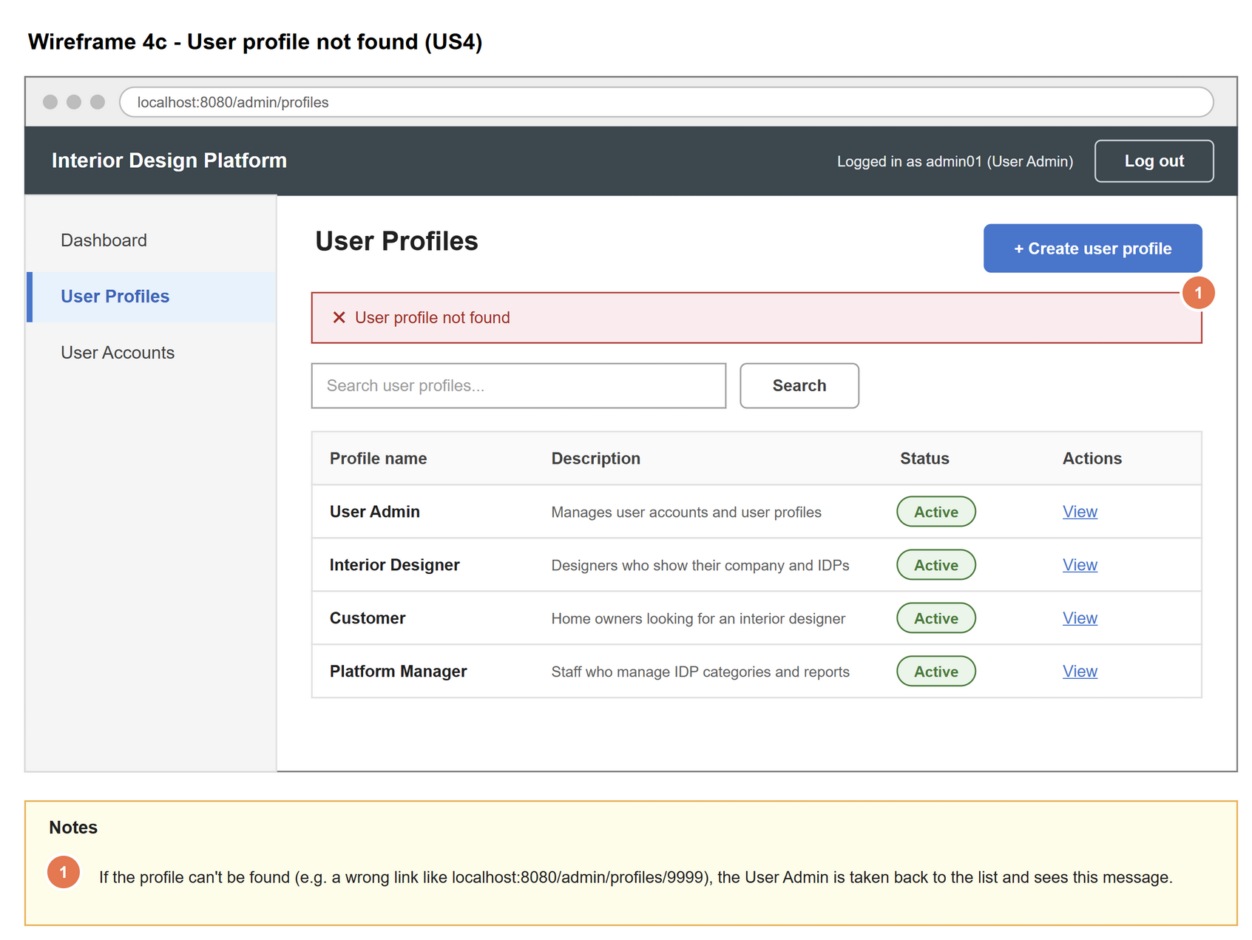
Figure 4: Wireframe 4c - User profile not found (US4)

5. B-C-E class diagram
The solid arrow means the boundary calls the controller. The dashed arrow means the controller uses the entity class. Only the operations needed for this use case are shown.
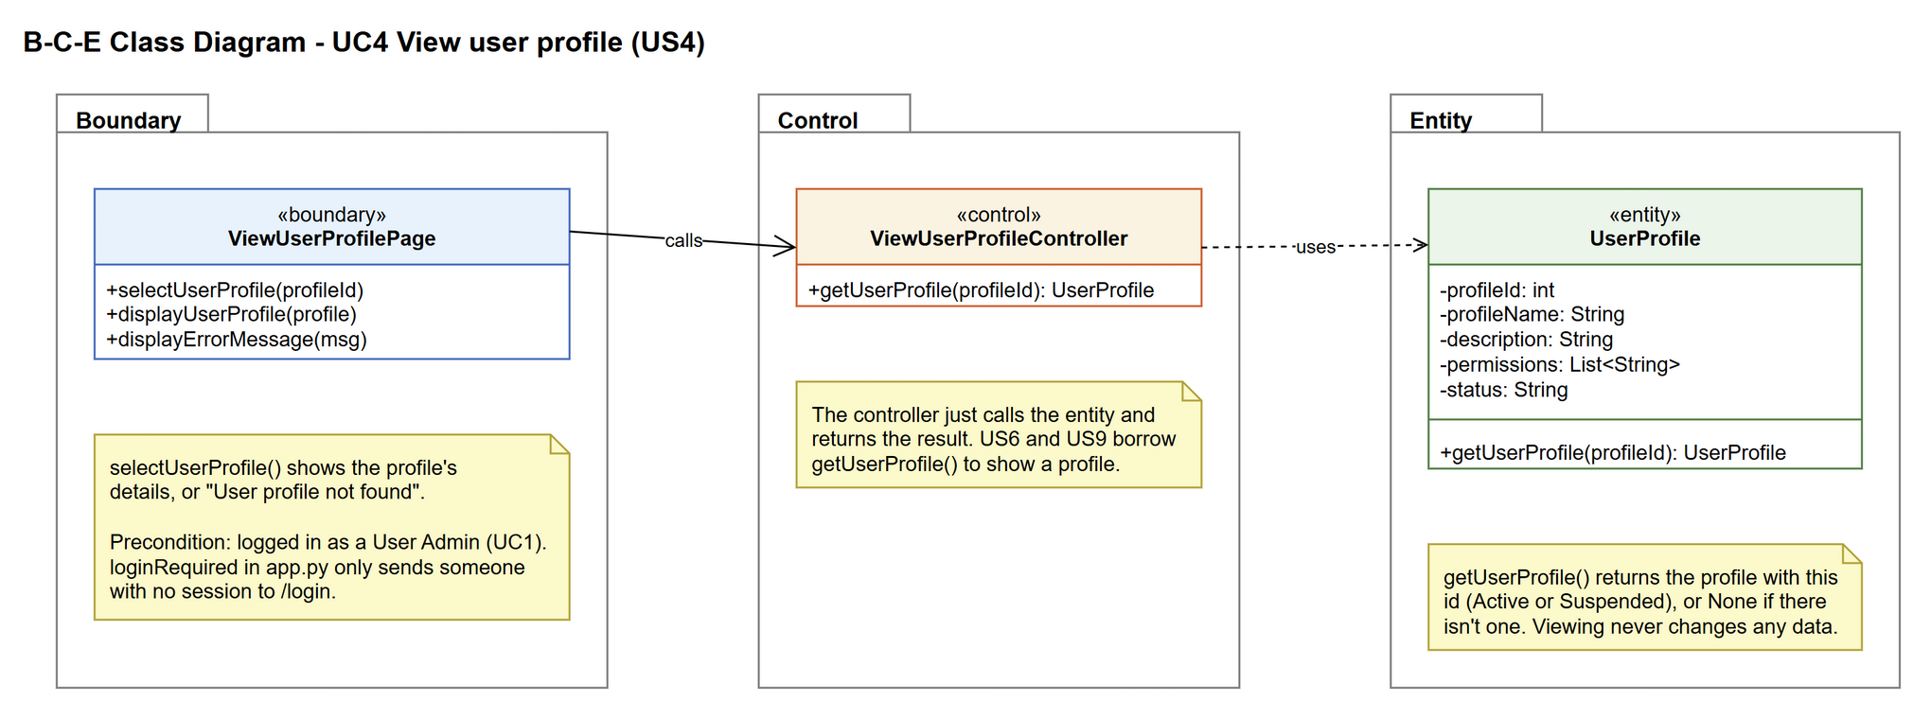
Figure 5: B-C-E class diagram for US4 View user profile
Layer | Class | What it does
Boundary | ViewUserProfilePage | The profile details page. Shows the profile, or a not-found message if there is no profile.
Control | ViewUserProfileController | Controller for UC4. Asks UserProfile for the profile with this id and passes it back to the page. US6 and US9 borrow getUserProfile() to show a profile.
Entity | UserProfile | The user group. getUserProfile() loads one profile from the database, or returns None if the id doesn't exist.

6. Sequence diagram
The sequence diagram follows UC4. The page passes the selected profile id to the controller, which gets the profile from UserProfile (step 2). The alt box shows the basic flow, where the details are shown (step 3), and alternative flow 2a, where the profile is not found.
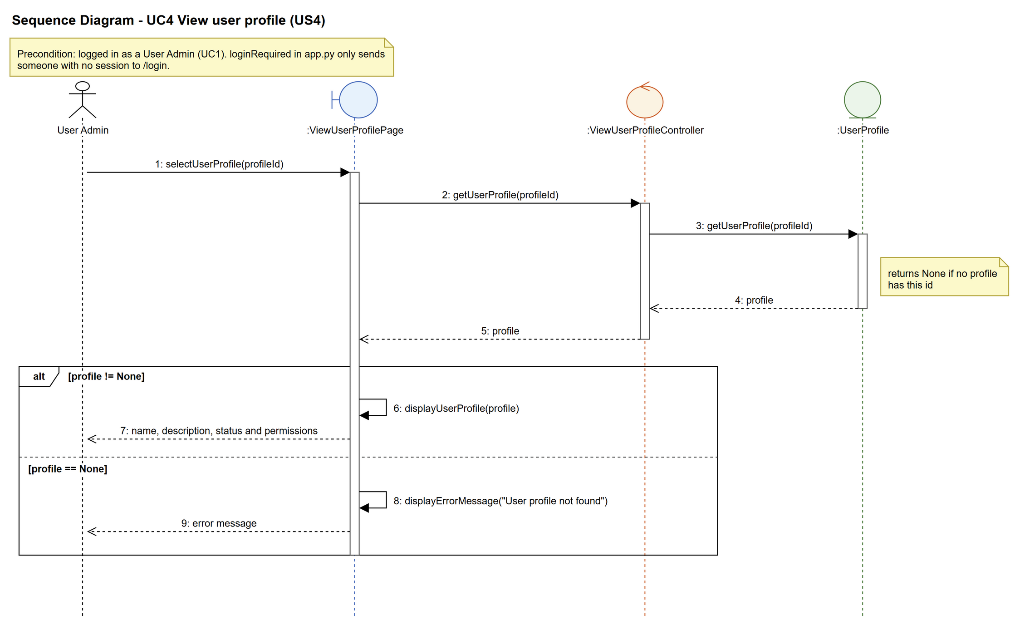
Figure 6: Sequence diagram for UC4 View user profile

7. Test cases
Test data used below: user profiles User Admin (id 1), Interior Designer (id 2), Customer (id 3) and Platform Manager (id 4), all Active. User accounts admin01 / Admin@123 (User Admin, Active), admin02 / Admin@123 (User Admin, Suspended), designer1 / Pass@123 (Interior Designer, Active) and cust001 / Cust@123 (Customer, Active).

7a. System test cases (black box)
Equivalence partitioning and boundary value analysis were used to pick the test data. Fill in "Actual result" and "Pass/Fail" after running each test.
Test ID | Scenario | Prerequisites | Test steps | Test data | Expected result | Actual result | Pass / Fail
TC4.1 | View an active profile | Logged in as admin01, on the User Profiles page. | 1. Click "View" next to Customer | Profile: Customer (id 3) | The details page shows name Customer, its description, status Active and the permission "Search, view and save IDPs" - the same as in the database.
TC4.2 | View a profile with several permissions | Same as TC4.1. | 1. Click "View" next to User Admin | Profile: User Admin (id 1) | Both permissions (Manage user accounts, Manage user profiles) are listed.
TC4.3 | View a suspended profile | The Customer profile is Suspended. | 1. Click "View" next to Customer | Profile: Customer (id 3) | The details are shown with the status "Suspended".
TC4.4 | Profile does not exist | Logged in as admin01. | 1. Type the address into the browser | localhost:5000/profiles/9999 | The User Profiles list is shown with "User profile not found". No error page.
TC4.5 | Viewing does not change data | Note down the Customer record in the database. | 1. View Customer  2. Click "Back to list"  3. Check the database again | Profile: Customer (id 3) | The record is exactly the same as before.
TC4.6 | Not logged in | Logged out. | 1. Type the address into the browser | localhost:5000/profiles/3 | Redirected to the login page. No profile details are shown.
TC4.7 | Back to list | On the Customer details page. | 1. Click "Back to list" | - | The User Profiles list is shown.

7b. Unit test cases (for TDD)
These are written before the code (test-driven development) and run automatically in the CI pipeline. They cover normal inputs, abnormal inputs and boundary values.
Test ID | Class and method | Input / setup | Expected output | Type | Pass / Fail
UT4.1 | UserProfile.getUserProfile() | 1 | Returns the User Admin profile with 2 permissions | Normal
UT4.2 | UserProfile.getUserProfile() | 3 (Customer set to Suspended first) | Returns the Customer profile with status "Suspended" | Normal
UT4.3 | UserProfile.getUserProfile() | 9999 | Returns None | Abnormal
UT4.4 | UserProfile.getUserProfile() | -1 | Returns None (no error thrown) | Abnormal
UT4.5 | ViewUserProfileController.getUserProfile() | 3 | Returns the same profile as UserProfile.getUserProfile(3) | Normal
UT4.6 | ViewUserProfileController.getUserProfile() | 0 | Returns None (no error thrown) | Boundary

